**Final Report**

2019250140 Jeon in a

**1. Introduction**

In this experiment, we hypothesized that Gq-DREADD induced excitotoxicity of neuronal cells in dentate gyrus will cause seizure behavior in mouse.

Excitotoxicity is defined as cell death resulting from the toxic actions of excitatory amino acids. Because glutamate is the major excitatory neurotransmitter in the mammalian central nervous system (CNS), neuronal excitotoxicity usually refers to the injury and death of neurons arising from prolonged exposure to glutamate and the associated excessive influx of ions into the cell. The resulting calcium overload is particularly neurotoxic, leading to the activation of enzymes that degrade proteins, membranes and nucleic acids. Excessive activation of glutamate receptors can result in neuronal dysfunction and death, a process called excitotoxicity. There is an excess of glutamate and glutamatergic activity in certain neurodegenerative diseases[1].

In the animal models of neurodegeneration, excitotoxicity is commonly induced experimentally by chemical convulsants, particularly by kainic acid (KA). Administration of KA has widely been used as a tool to explore the mechanism involved in excitotoxicity[2]. The exact molecular mechanisms by which KA induces excitotoxicity and cell death remain unclear; however, oxidative stresses and the activation of proinflammatory cytokines are major contributors. Additionally, KA increases neuronal excitability, production of reactive oxygen species (ROS), and lipid peroxidation. Both in vitro and in vivo studies demonstrate that KA induces cell death via accumulation of intracellular calcium, which stimulates ROS production and mitochondrial dysfunction, thereby leading to neuronal cell death. Besides oxidative stress and intracellular calcium overload, KA can activate the glutamate receptors leading to depletion of neuronal energy stores and thereby activating pathways of energy metabolism[3].

Neurodegeneration involves the progressive loss of structure and function of neurons. Various types of biological mechanism have been implicated in neurodegeneration. Excitotoxicity is considered to be a major mechanism of neuronal death in acute and chronic neurodegenerative diseases, such as Alzheimer's disease (AD), Parkinson's disease (PD), Huntington's disease (HD), temporal lobe epilepsy (TLE), and amyotrophic lateral sclerosis (ALS)[2].

For hypothesis verification, the DREADD system is used. Designer Receptors Exclusively Activated by Designer Drugs (DREADDs) are genetically modified G-protein-coupled receptors (GPCRs), that can be activated by a synthetic ligand which is otherwise inert at endogenous receptors. DREADDs can be expressed in cells in the central nervous system (CNS) and subsequently offer the opportunity for remote and reversible silencing or activation of the target cells when the synthetic ligand is systemically administered[4]. There are many advantages to use DREADD. Depending on the DREADD, it could be precisely controled Gq, Gi or Gs-signaling pathways. Also DREADDs and the designer drugs are non-toxic so that the neurons can keep healthy. Using DREADDs and corresponding designer drugs allows us to modify neuronal activity non-invasively in in vivo models[5].

**2. Experiment condition**

1) Stereotaxic viral injection: Gq-DREADD (AAV-hsyn-hM3Dq-mCh) to dentate gyrus (both side)

2) Wait for Gq-DREADD expression by 3 weeks

3) CNO administration (1mg/kg/day by eye drop) for 5 times

4) Measure seizure activity

5) Sacrifice at 3 hours after the last CNO application because of the activation of c-fos

6) IHC for analyzing cell death

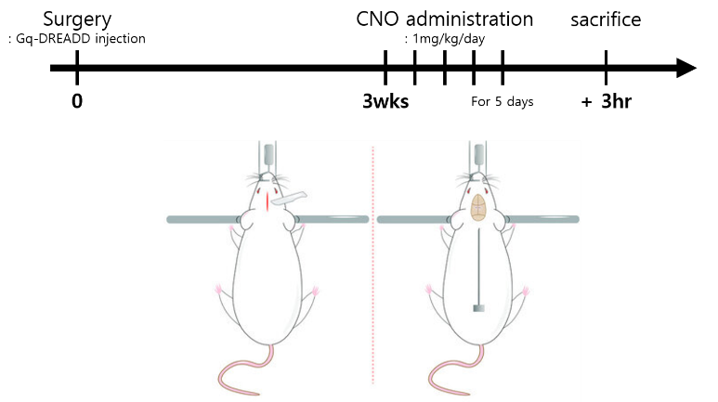

**3. Figure**

(1) Representative images

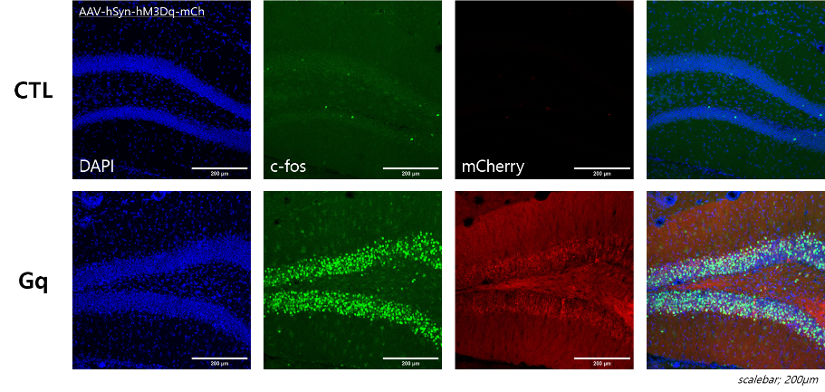

(2) Cell density

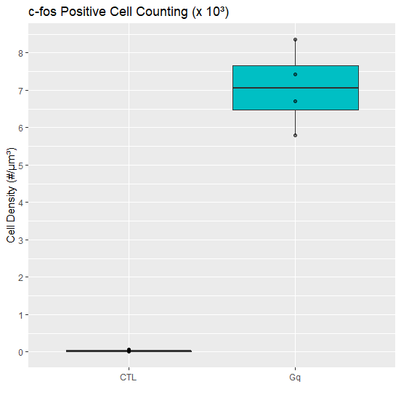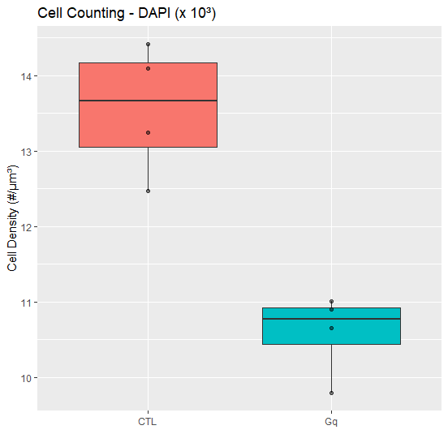

**4. Discussion**

The representative images showed that the hippocampus cell number of Gq-DREADD injected mouse is less than control group. Meanwhile, c-fos positive cell number is more than control group. For accuracy, we used imageJ that can measure cell density. As shown above, the hippocampus cell density of Gq-DREADD injected mice is significantly less than control group and c-fos much more activitated. Each groups consisted of four data. The c-fos positive cell density was calculated to confirm the activity of neuron, and DAPI was identified to measure the density of the neuron.

Through this experiment, we can think that repetitive and excessive excitatory stimulation can induce neuronal death. Especially, I think that KA is involved in excitotoxicity.

**5. Reference**

[1] Ullah, I., Park, H.Y. and Kim, M.O., Anthocyanins Protect against Kainic Acid-induced Excitotoxicity and Apoptosis via ROS-activated AMPK Pathway in Hippocampal Neurons. CNS Neurosci Ther, 20: 327-338. (2014). https://doi.org/10.1111/cns.12218

[2] Mohd Sairazi, Nur Shafika et al. “Kainic Acid-Induced Excitotoxicity Experimental Model: Protective Merits of Natural Products and Plant Extracts.” *Evidence-based complementary and alternative medicine : eCAM* vol. 2015 (2015): 972623. doi:10.1155/2015/972623

[3] Dong, Xx., Wang, Y. & Qin, Zh. Molecular mechanisms of excitotoxicity and their relevance to pathogenesis of neurodegenerative diseases. *Acta Pharmacol Sin* **30,**379–387 (2009). https://doi.org/10.1038/aps.2009.24

[4] Pickering CA, Mazarakis ND. Viral Vector Delivery of DREADDs for CNS Therapy. Curr Gene Ther. 2021;21(3):191-206. (2021). doi: 10.2174/1566523221666210211102435. PMID: 33573551.

[5] https://hellobio.com/dreadds/

[6] Roth, Bryan L. “DREADDs for Neuroscientists.” *Neuron* vol. 89,4: 683-94. (2016). doi:10.1016/j.neuron.2016.01.040